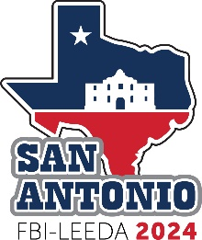
FBI LEEDA 32nd Annual Executive Training Conference
April 28-May 1, 2024 – San Antonio, Texas

Letter of Request to Attend Law Enforcement Conference

This is a suggested template for a letter you can draft to request employer support for your attendance at the FBI-LEEDA 32nd Annual Executive Training Conference, April 28-May 1, 2024 in San Antonio, Texas. If you decide to use it, please make sure you include your agency and supervisor’s name.

Dear [Supervisor’s name],

This is to request approval to attend the FBI LEEDA 32nd Annual Executive Training Conference, April 28-May 1, 2024 at the Grand Hyatt San Antonio Hotel in San Antonio, Texas. I believe that attending this conference will benefit me and our agency with the conference’s relevant educational sessions and networking opportunities with colleagues from across the nation. This event attracts 400+ like-minded police leaders offering the best format for idea-exchange.

All topics to be covered are important to law enforcement today and will be presented by nationally known, highly respected subject matter experts.

FBI-LEEDA provides enormous value for the money. The early bird registration fee is $425.00 for FBI-LEEDA Member Delegates and $500.00 for Nonmember/Criminal Justice Delegates. The fee covers all the following sessions and meals:

Training Sessions - all sessions offered at the Conference (15+ hours of training)
Meals - 3 breakfasts, 3 lunches and 3 evening meals

The group rate lodging for this Conference is $249 + tax per night for 4 nights ($1,100 estimated).

FBI-LEEDA promotes the Annual Executive Education Conference as world-class education that is unparalleled in our field. For the benefits that I expect to derive from this conference, I believe that the costs are reasonable and I hope you will support my attendance.

Sincerely,

[Your name]

